附 录

附录A 英译汉
一、英文原文
Source: Li J., Ye J. Edge-YOLO: Lightweight Infrared Object Detection Method Deployed on Edge Devices. Applied Sciences, 2023, 13(7), 4402. https://doi.org/10.3390/app13074402.

Edge-YOLO: Lightweight Infrared Object Detection Method Deployed on Edge Devices
Junqing Li, Jiongyao Ye, Dimitris Mourtzis
School of Information Science and Engineering, East China University of Science and Technology, Shanghai 200237, China; lijq2020@outlook.com

Abstract
Existing target detection algorithms for infrared road scenes are often computationally intensive and require large models, which makes them unsuitable for deployment on edge devices. In this paper, we propose a lightweight infrared target detection method, called Edge-YOLO, to address these challenges. Our approach replaces the backbone network of the YOLOv5m model with a lightweight ShuffleBlock and a strip depthwise convolutional attention module. We also applied CAU-Lite as the up-sampling operator and EX-IoU as the bounding box loss function. Our experiments demonstrate that, compared with YOLOv5m, Edge-YOLO is 70.3% less computationally intensive, 71.6% smaller in model size, and 44.4% faster in detection speed, while maintaining the same level of detection accuracy. As a result, our method is better suited for deployment on embedded platforms, making effective infrared target detection in real-world scenarios possible.
Keywords: infrared object detection; lightweight network; convolutional attention; YOLOv5; RK3588

1. Introduction
Visible light images are commonly used in target detection due to their high resolution, definition, and detailed visual information that is easily interpreted by the human eye. However, these images are sensitive to external factors such as weather and lighting conditions, which can reduce image quality and negatively impact target detection accuracy. This is where infrared imaging technology plays a crucial role. By overcoming these limitations, infrared imaging allows for image acquisition under diverse lighting and weather conditions, including foggy days and nighttime scenarios. As a result, this technology has been widely adopted in various fields, such as autonomous driving, security monitoring, and remote sensing, and offers a broader range of use cases than visible images. Therefore, the importance of infrared imaging technology in enabling efficient and reliable target detection cannot be overstated.
Traditional infrared target detection techniques [1,2,3] are mainly model-based methods, such as template matching, threshold segmentation, and the Hausdorff metric. However, with the development of deep learning, target detection techniques based on convolutional neural networks have emerged in recent years. These methods are primarily divided into two-stage algorithms (e.g., Faster-RCNN [4]) and single-stage algorithms (e.g., SSD [5] and YOLO [6]). The single-stage algorithm is designed to achieve a balance between detection speed and accuracy, resulting in a significant improvement in detection speed while maintaining accuracy compared with the two-stage algorithm. Consequently, the YOLO series has become a widely used representative of the single-stage algorithm. Among the mainstream YOLO algorithms, YOLOv5 (version 6.2) has achieved significant improvement in both detection accuracy and speed compared with its predecessor by using Mosaic data enhancement, C3 modules, and an improved SPPF module. Although YOLOv5 performs well on visible images, it encounters several challenges when applied to infrared detection. The first major issue is that infrared images suffer from poor contrast, high noise, and blurred imaging, leading to the loss of crucial target features during deep convolutional network processing. Moreover, since infrared images lack color information, and the difference between target and background features is minimal, it becomes challenging for deep convolutional neural networks to distinguish useful information from irrelevant data, reducing detection accuracy. Another significant challenge is that embedded devices commonly used in autonomous driving and security monitoring fields have limited computing power, storage space, and power consumption, which makes deploying large target detection models such as YOLOv5 difficult. Additionally, these fields require real-time detection, and collecting data on edge devices and sending them to the server for detection and analysis can lead to network latency and communication congestion problems in widely distributed areas.
The challenges mentioned above necessitate lightweight infrared target detection on edge devices. In summary, this paper proposes a solution to these issues by introducing Edge-YOLO, an infrared target detection algorithm that utilizes lightweight networks and attention mechanisms specifically designed for edge devices. The primary enhancements of this algorithm can be summarized as follows:
(1) The bounding box loss function was redesigned, and a loss function with a power hyperparameter α was made to accelerate the convergence of the loss function and solve the uncertainty of the aspect ratio in CIoU;
(2) A lightweight content-aware up-sampling operator was adopted, which can obtain a larger perceptual field than the original nearest-neighbor up-sampling method, while only introducing a small number of parameters and computational cost;
(3) The feature extraction network was reconstructed based on the improved ShuffleNetv2, which enhances the extraction ability of strip features in IR scenes and the perception ability of salient features in IR images by embedding a newly designed strip depthwise convolutional attention module in ShuffleBlock while significantly reducing the computational power of the network.
The remaining sections of this paper are organized as follows: Section 2 provides an overview of related works on target detection with neural networks, including YOLOv5, and other algorithms in infrared target detection. Section 3 provides a detailed introduction to the Edge-YOLO algorithm proposed in this paper. Section 4 presents the results of various experiments conducted to evaluate the performance of Edge-YOLO. Finally, Section 5 summarizes the main contributions of this paper.
2. Related Works
The YOLO family of algorithms, known for their efficiency and simplicity, was first introduced by Redmon et al. in 2015. In the years that followed, Redmon et al. released YOLOv2 and YOLOv3 algorithms, which further reduced network complexity and improved detection speed compared with two-stage algorithms [7]. After Redmon withdrew from the field of computer vision, Glenn Jocher released YOLOv5 in 2020, which has since been updated to version 6.2. YOLOv5 is composed of a backbone feature extraction module, a neck feature fusion module, and a head detection module, as illustrated in Figure 1. The algorithm incorporates five different scales of n, s, m, l, and x, with larger scales delivering higher detection accuracy but slower real-time performance. However, the network structure of the models of different scales remains consistent, differing only in the number of partial layers, and is represented uniformly as “×n” in the figure. YOLOv5 uses CSPDarknet53 as its backbone network, which includes the Cross Stage Partial (CSP) structure [8]. The CSP structure integrates gradient changes in the feature map, reducing the problem of repeating gradient information in the backbone network. Moreover, YOLOv5 utilizes a bottleneck structure with residual connections in the backbone network to prevent network degradation due to gradient disappearance, and a bottleneck structure without residual connections in the feature fusion layer to reduce computational effort. Additionally, Jocher employs a modified Spatial Pooling Pyramid Fast (SPPF) structure in place of the original SPP [9]. The modified SPPF achieves the same computational results as the original parallel MaxPool layers of three different sizes by serializing multiple MaxPool layers of the same size, significantly reducing computational time.
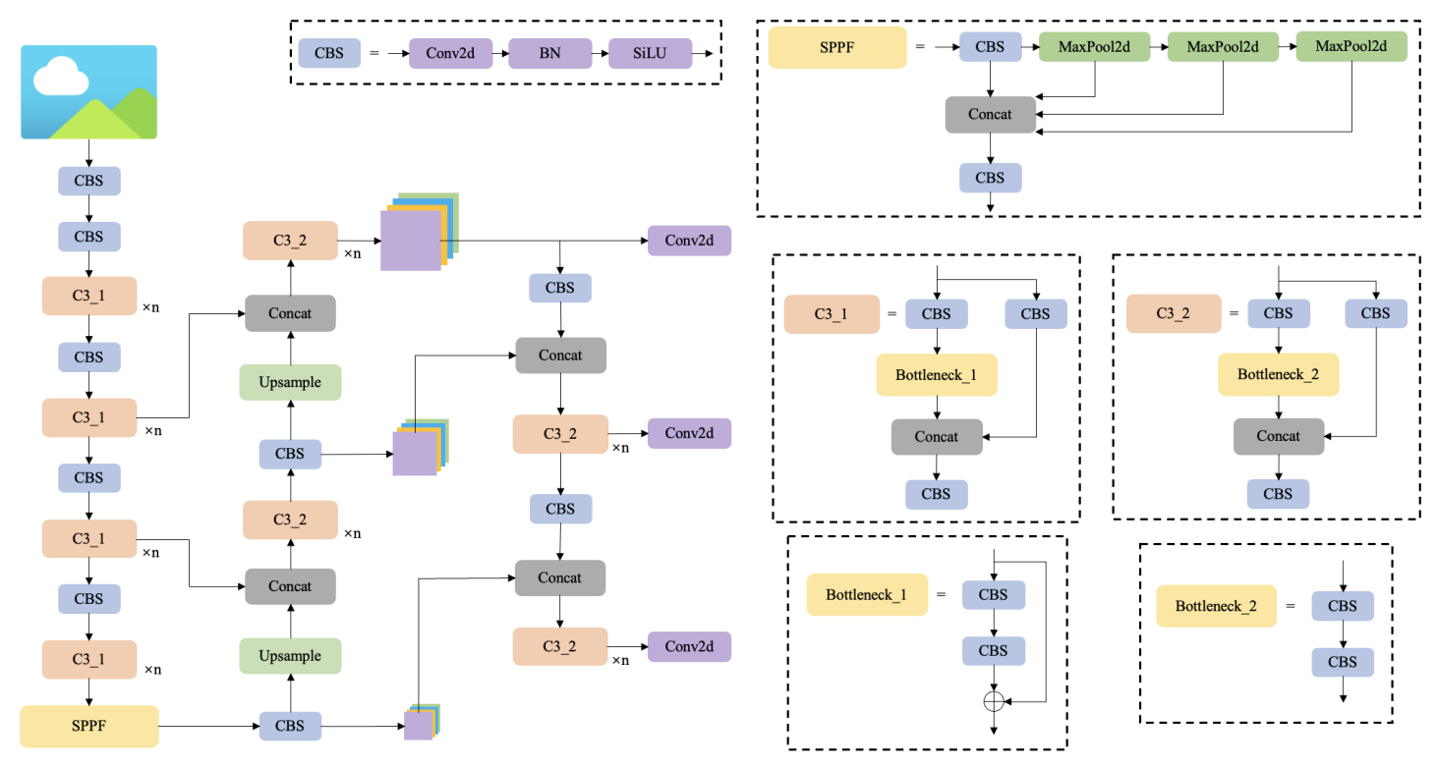
Figure 1. The network structure of YOLOv5 series (including n, s, m, l, and x, depending on the number of duplicates of module C3).

In addition to YOLOv5, various target detection methods have been proposed for infrared scenes by researchers. Li et al. [10] proposed the YOLO-FIRI model, an infrared image area-free target detector based on YOLOv5. They achieved good infrared target detection performance by improving the CSP structure and introducing multiple detection heads. Fan et al. [11] improved the feature extraction capability by using dense connection blocks based on YOLOv5, and improved the detection accuracy by adding a channel focus mechanism and modifying the loss function. Dai et al. [12] proposed TIRNet, which adopted VGG as the feature extractor and used a continuous information fusion strategy to obtain more accurate and smoother detection results. Li et al. [13] designed a dense nested interactive module to achieve progressive interaction among high-level and low-level features. You et al. [14] utilized multiscale mosaic data augmentation to enhance the diversity of objects and proposed a parameter-free attention mechanism to enhance features. Although these methods can be applied to IR target detection, they have some drawbacks. For instance, striped targets in IR road scenes require a more reasonable combination of striped convolution and traditional convolution to extract features. The bounding box loss function of the algorithm needs to be more accurately adapted to the boundary regression of targets in IR images, and the model needs to be more lightweight to be suitable for practical edge devices. Therefore, the method in this paper focuses on improving the above shortcomings.
3. Methods
The structure of our Edge-YOLO model is shown in Figure 2 below.
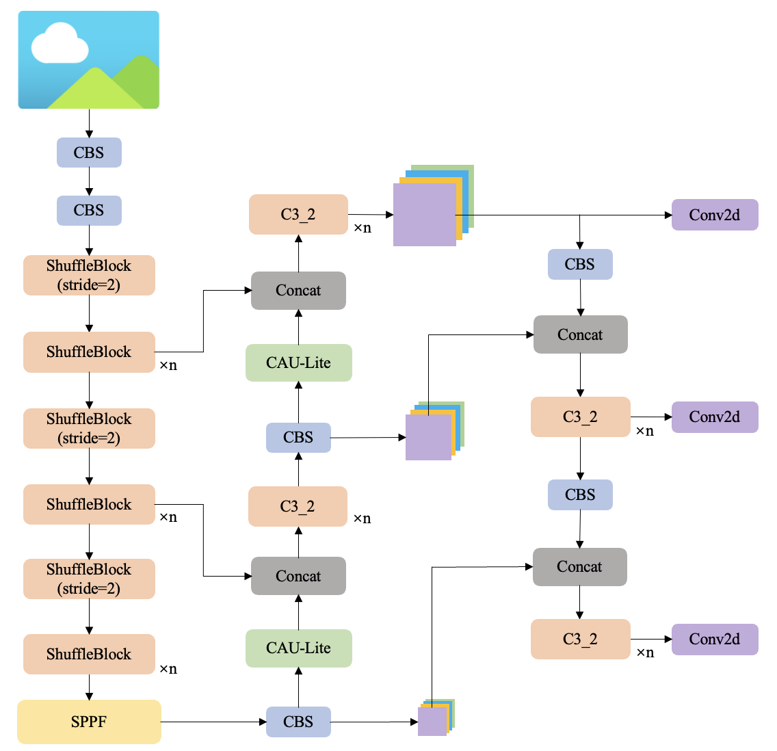
Figure 2. The network structure of Edge-YOLO.

Firstly, the backbone of the model uses the improved ShuffleBlock to replace the C3 module in YOLOv5 to enhance the feature extraction capability for the characteristics of IR images of road scenes while reducing the complexity of the model.
Secondly, in the feature up-sampling structure, the original nearest-neighbor up-sampling operator is replaced by the improved CAU-Lite module.
Thirdly, although not shown in the figure, we utilize the recently proposed EX-IoU instead of CIoU as the bounding box loss function of our model. This new loss function provides better and more accurate convergence during training, thus leading to improved detection performance.
3.1. Improved Bounding Box Loss Function EX-IoU
The latest version of the YOLOv5 algorithm (version 6.2) uses the Complete-IoU (CIoU) as its bounding box loss function, as proposed by Zheng [15]. The CIoU integrates three aspects of the intersection–union ratio (IoU) between the predicted box and the ground truth box: the ratio of the distance between their centroids to the length of the diagonal of the minimum outer rectangle, and the similarity of their aspect ratios. The equation for the CIoU is as follows:
$$L_{CIoU}=1-IoU+\frac{ρ^{2}(b,b^{gt})}{c^{2}}+αv$$  $$α=\frac{v}{\left((1-IoU)+v\right)}$$  $$v=\frac{4}{π^{2}}{\left(arctan\frac{w^{gt}}{h^{gt}} - arctan\frac{w}{h}\right)}^{2}$$ | (1)
where α is the weight coefficient, ρ(b,bgt) is the distance between the center point of the predicted box and the ground truth box, c is the diagonal length of the minimum outer rectangle, v indicates the difference between the aspect ratio of the predicted box and the ground truth box, and v is 0 if they have the same aspect ratio.
The CIoU metric used in the current version of the YOLOv5 algorithm is designed to integrate three aspects of the intersection–union ratio IoU between the prediction box and the ground truth box. However, the aspect ratio used in CIoU is a relative value, which can introduce uncertainty during calculation and potentially hinder the optimization of the model. To address this issue, we propose the use of Efficient-IoU (EIoU) as the bounding box loss function, as proposed by Zhang et al. [16]. EIoU splits the aspect ratio based on CIoU and replaces the original aspect ratio difference between the predicted box and ground truth box with the ratio of the width difference between the predicted box and the ground truth box to the width of the minimum circumscribed rectangle, and the ratio of the height difference to the height of the minimum outer rectangle. This approach leads to a more accurate bounding box loss function and facilitates better model optimization. The formula is as follows:
$$L_{EIoU}=1-IoU+\frac{ρ^{2}(b,b^{gt})}{c^{2}}+\frac{ρ^{2}(w,w^{gt})}{{C_{w}}^{2}}+\frac{ρ^{2}(h,h^{gt})}{{C_{h}}^{2}}$$ | (2)
where Cw and Ch denote the width and height of the minimum outer rectangle, respectively. The literature [17] proposes to use the hyperparameter α as a power on each term in the loss function IoU, with the following simplified formula.
$$L_{α-IoU}=1-{IoU}^{α}$$ | (3)
The parameter α is crucial in emphasizing the importance of the loss and gradient of objects with high IoU, thereby enhancing the accuracy of the bounding box regression. To improve the bounding box loss function, this paper incorporates the power α into the EIoU equation, resulting in a new function known as EX-IoU. This function exponentially magnifies the importance of the IoU value, centroid distance, width difference, or height difference between any predicted box and the ground truth box, leading to an exponential reduction effect on losses and an improvement in the accuracy of the bounding box regression. The optimal value of α is determined through experiments discussed in Section 4.
$$L_{EX-IoU}=1-{IoU}^{α}+\frac{ρ^{2α}(b,b^{gt})}{c^{2α}}+\frac{ρ^{2α}(w,w^{gt})}{{C_{w}}^{2α}}+\frac{ρ^{2α}(h,h^{gt})}{{C_{h}}^{2α}}$$ | (4)
3.2. Content-Aware Lightweight Up-Sampling Operator CAU-Lite
Up-sampling is a crucial operation in the Feature Pyramid Network (FPN [18]), and the two commonly used methods for up-sampling are linear interpolation and deconvolution. Linear interpolation methods, such as nearest neighbor interpolation and bilinear interpolation, only take into account the sub-pixel neighborhood of the current pixel, which results in insufficient semantic information and limited receptive fields. On the other hand, the deconvolution method expands the dimensionality of the feature map through convolution, but it applies the same convolution kernel across the entire feature map, which makes it challenging to capture local changes and variations in the feature map. Furthermore, this method introduces a large number of parameters and computational overhead into the network. The CARAFE proposed by Wang et al. [19] compensates the shortcomings of the above two types of methods to some extent: CARAFE perceives and aggregates contextual information within a larger reception field, and instead of applying a fixed convolution kernel to all features, it dynamically generates adaptive up-sampling kernels, and then reorganizes the features based on the predicted up-sampling kernels. The up-sampling kernel prediction module of CARAFE changes the dimensionality of the input feature map by convolution layer to generate a feature map with the channel number of σ2kup2, where σ indicates the up-sampling rate (generally 2) and kup indicates the size of the up-sampling kernel (the value in this paper is 5), and then uses the pixel shuffle method to expand the channel dimension in the spatial dimension to obtain an up-sampling kernel map with the shape of σH×σW×kup2, which contains σH×σW up-sampling kernels. Each position of the output feature map is then mapped back to the input feature map in the feature reassembly module. The region of kup×kup, the center of the map, is taken out and dotted with the predicted up-sampling kernels at that point to obtain the result. Each channel at the same spatial location on the feature map uses the same up-sampling kernel.
The analysis reveals that CARAFE uses a zero-padding strategy on the feature map edge positions in the feature reorganization stage, which leads to imperfect edge information of the up-sampled images and it is difficult to correctly upsample the target features at the edge of the feature map. Based on this, this paper proposes an improved Content-Aware Up-Sampling-Lite (CAU-Lite) method to replace the nearest neighbor up-sampling method in YOLOv5. Before finding the neighborhood of kup×kup, the nearest neighbor interpolation is used to upsample the input feature map, so that the spatial dimension of the feature map is the same as the spatial dimension of the up-sampled kernel map. Then, at each spatial position in the feature map, the element with the size 1×1×kup2×C is taken out and reshaped to the size of kup×kup×C. At the same time, the upper sampling core of 1×1×kup2 is reshaped at the corresponding position in the upper sampling core map to the size of kup×kup×1. The product of each channel of the feature map with the upper sampling core is dotted to obtain a result with the size 1×1×C, and the result obtained for all channels is the result of the corresponding position in the output feature map. The improved CAU-Lite structure and calculation process are shown in Figure 3.
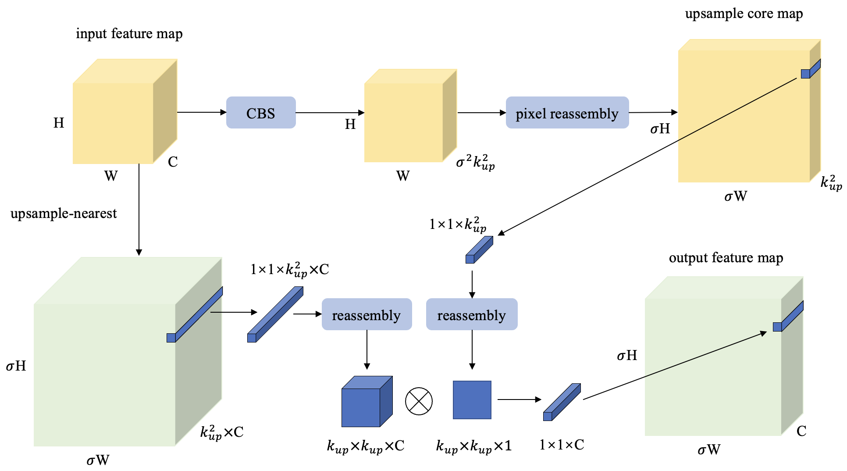
Figure 3. Structure of CAU-Lite.

3.3. YOLOv5 Network Model Improvement
The YOLOv5 algorithm is mainly designed for the visible light domain and is better suited for deployment on GPUs due to its high number of model parameters, large computational requirements, and large model size. However, the objective of this paper is to create lightweight target detection networks for edge-embedded devices, making it reasonable to employ a lightweight network structure instead of the heavy CSPDarknet backbone network of YOLOv5. One promising candidate for such a lightweight network model is ShuffleNetv2, proposed by Ma et al. of Megvii’s team [20], which achieves a good balance between model accuracy and running speed. By using lightweight structures such as grouped convolution and depthwise convolution, ShuffleNetv2 is optimized for computational complexity, storage access cost, and parallelism, resulting in a noticeable improvement in actual running speed. In light of this, we chose to use an improved version of ShuffleNetv2 as the backbone network structure of the Edge-YOLO algorithm. The following problems usually exist in IR road scenes:
(1) Compared with visible light images, original infrared images lack detailed texture and feature complexity, making them less susceptible to network perception, especially in deeper and complex networks where features are lost and additional noise is introduced.
(2) In road scenes, pedestrians and bicycles are typically present in slender strips rather than regular shapes. However, traditional convolution layers use regular convolution kernels (N × N), which may result in a loss of feature information due to their inability to adapt to target shape changes.
To enhance the extraction capability of strip-shaped features in IR scenes and the perception of salient features in IR images without increasing computational effort, this paper proposes embedding the strip depthwise convolutional attention module (SDCA) into ShuffleBlock. As shown in Figure 4, SDCA takes an input and generates a shortcut branch. The local information is aggregated by a 5 × 5 depthwise convolution, and the output is convolved by three branches: a pair of 1 × 7 and 7 × 1 depthwise strip convolutions, a pair of 1 × 11 and 11 × 1 depthwise strip convolutions, and a shortcut branch. These branches capture multi-scale contextual information and strip features, and their results are summed and passed through a 1 × 1 normal convolutional layer to model the relationship between different channels. The output of this layer is then used as the attention weights to weigh the input of SDCA by multiplying it with the generated shortcut branch.
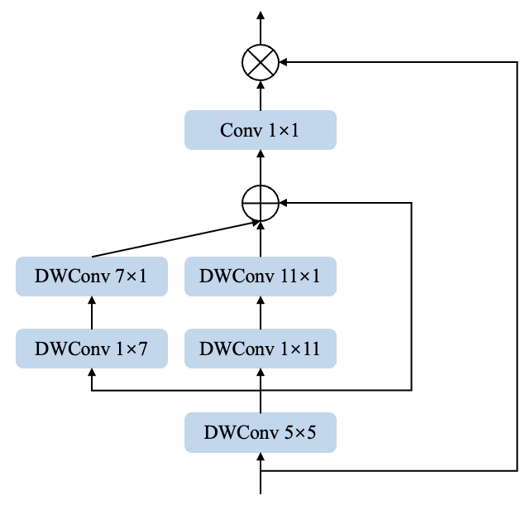
Figure 4. Strip depthwise convolutional attention module.

The improved structure obtained by embedding the strip depthwise convolutional attention module into ShuffleBlock, as well as the addition of SENet [21] as the channel attention mechanism in the right branch, are shown in Figure 5. Typically, 1 × 1 convolutions are used before and after depthwise convolutions to fuse information between channels and to increase or decrease the number of channels. However, the original ShuffleBlock uses 1 × 1 convolution layers before and after the depthwise convolution layer in its right branch, which generates redundancy. To reduce the number of parameters and computational demand, this paper removes the 1 × 1 convolution layer after the depthwise convolution.
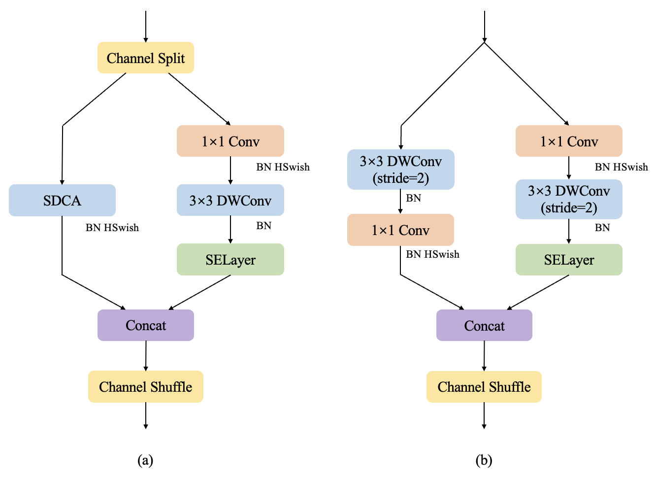
Figure 5. Improved ShuffleBlock. (a): the base unit with SDCA applied; (b): the base unit for down-sampling (2×).

4. Experiments
4.1. Experimental Environment and Dataset
The experiments in this paper were conducted using an Intel Xeon Platinum 8255C CPU and an NVIDIA RTX 3090 GPU with CUDA version 11.7. To evaluate the detection performance of Edge-YOLO, we used the publicly available FLIR dataset, which is an infrared dataset released by FLIR in 2018. The dataset consists of more than 10,000 images classified into four categories: Person, Bicycle, Car, and Dog. However, since there are only a few Dog images in the dataset, this paper only evaluated the detection performance of Edge-YOLO for the remaining three categories.
4.2. Bounding Box Hyperparameter Study
In the improved EX-IoU bounding box loss function of this paper, there is a hyperparameter α that affects the model’s accuracy performance. To determine the optimal value of α for the Edge-YOLO algorithm, we conducted multiple training and testing experiments using different values of α. The accuracy results obtained are shown in Figure 6. From the results, it can be observed that the highest mAP value of 78.8% is achieved when the value of α is set to 3, while the mAP value of the model decreases to 76.9% when the value of α is set to 8. This indicates that the model’s detection accuracy improves by 2.47% when using the optimal value of α, and the model achieves its best performance in terms of detection performance. As a result, this paper selects 3 as the power of each term in EX-IoU to obtain the best accuracy performance.
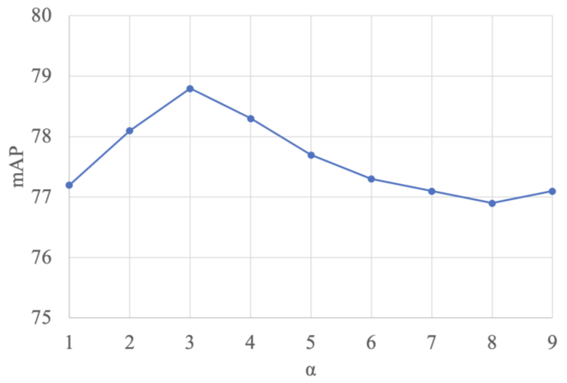
Figure 6. Variation in accuracy for different values of α on the algorithm.

4.3. Model Lightweighting Experiment
By replacing the backbone feature extraction network of YOLOv5 with the improved ShuffleBlock in this paper, i.e., Edge-YOLO shown in Figure 2, the overall number of parameters, computation, and model size of the algorithm model can be effectively reduced, and Table 1 below shows the comparison of each parameter after the model is lightened and improved.
Table 1. Comparison of lightweight improvement effects.
Model | Params/M | Flops/G | Size/MB
YOLOv5m | 20.9 | 47.9 | 42.2
Edge-YOLO | 5.8 | 14.2 | 12.0

The table above shows that by replacing the backbone network with the improved ShuffleBlock, Edge-YOLO reduces the number of network parameters by 72.2%, the amount of computation by 70.3%, and the model size by 71.6% compared with YOLOv5m. This demonstrates the significant lightweight effect of the proposed method, which helps to reduce the storage and computation resources required by the model and is more suitable for deployment on edge-embedded devices.
4.4. Ablation Experiments
In this part, the original ShuffleNetv2 is firstly used as the backbone network of YOLOv5m, based on which the ablation experiments of several improvement strategies proposed in this paper are conducted to better understand the effects of different improvement strategies on the detection effect in Edge-YOLO, and the results are shown in Table 2 below.
Table 2. Ablation experiments.
+EX-IoU | +CAU-Lite | +SDCA | mAP@0.5/% | FPS | Params/M | Flops/G | Size/MB
 |  |  | 73.1 | 85.3 | 5.4 | 12.9 | 11.3
√ |  |  | 74.3 | 85.1 | 5.4 | 12.9 | 11.3
 | √ |  | 74.7 | 84.0 | 5.4 | 13.1 | 11.4
 |  | √ | 76.2 | 81.5 | 5.8 | 14.1 | 12.0
√ | √ | √ | 78.8 | 80.7 | 5.8 | 14.2 | 12.0

As can be seen from Table 2, compared with the first group of experiments using only the basic model, the second group of experiments with the addition of EX-IoU solves the problem of uncertainty in the aspect ratio of CIoU by improving the loss function of the bounding box and accelerating the convergence of the loss function, and the detection accuracy is improved by 1.2% from the results, while the remaining parameters remain unchanged. The third group of experiments replaces the original nearest neighbor interpolation up-sampling with the CAU-Lite up-sampling operator proposed in this paper, which senses and aggregates contextual information within a larger reception field, dynamically generates adaptive up-sampling kernels, and performs feature reorganization based on the generated up-sampling kernels. It can be seen that with CAU-Lite, the detection accuracy of the model is improved by 1.6%, but the FPS is also slightly reduced. The fourth group of experiments applies the strip depthwise convolutional attention module proposed in this paper, which replaces the original ShuffleNetv2 network structure with an improved ShuffleBlock, enhancing the feature extraction capability for strip-shaped targets and the perception of the saliency of infrared targets. As seen in the table, the detection performance of the model is significantly improved by 3.1% compared with the original model, but the number of parameters, computation, and size of the model increased due to the addition of the new module. The final fifth set of experiments uses a combination of the three improvement points proposed in this paper, and from the results, a larger performance improvement is obtained at the cost of fewer computational and storage resources compared with the original model.
Figure 7 below shows the P–R curves of each class of different improvement strategies applied to the base model and the complete Edge-YOLO. The figure shows that compared with the base model, the APs of all three target categories are improved with different improvement strategies, and the AP of the bicycle category is improved most significantly.
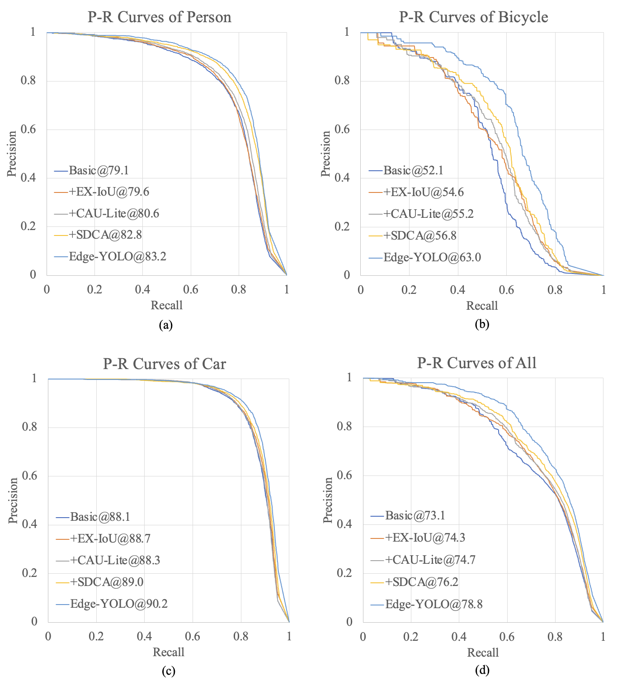
Figure 7. P–R curves for each class. (a): P-R curves of the class ‘Person’; (b): P-R curves of the class ‘Bicycle’; (c): P-R curves of the class ‘Car’; (d): P-R curves of all classes.

4.5. Comparison Experiments
To further verify the detection performance of the Edge-YOLO algorithm, this section compares Edge-YOLO with Faster R-CNN, SSD, YOLOv5m, YOLOv7 [22], and other mainstream target detection algorithms for comparison experiments, and the results are shown in Table 3 below.
Table 3. Comparison of mainstream target detection algorithms.
Model | AP@0.5/% |  |  | mAP@0.5/% | FPS | Params/M | Flops/G | Size/MB
 | Person | Bicycle | Car
Faster R-CNN | 76.6 | 50.4 | 85.7 | 70.9 | 17.6 | 66.1 | 152.7 | 133.5
SSD | 63.5 | 43.5 | 79.3 | 62.1 | 31.9 | 46.9 | 117.6 | 96.1
YOLOv5m | 83.8 | 64.1 | 90.6 | 79.5 | 55.9 | 20.9 | 47.9 | 42.2
YOLOv7 | 86.4 | 67.3 | 91.4 | 81.7 | 27.9 | 37.2 | 105.1 | 74.8
YOLO-FIRI | 79.5 | 52.4 | 88.6 | 73.5 | 71.4 | 7.2 | 20.4 | 15.0
Edge-YOLO | 83.2 | 63.0 | 90.2 | 78.8 | 80.7 | 5.8 | 14.2 | 12.0

From the table, we can first see that Faster R-CNN, as a two-stage algorithm, lags far behind the single-stage algorithm in detection speed, and the current detection accuracy does not have an advantage over the single-stage algorithm; while the SSD algorithm in the single-stage algorithm speeds up the detection speed compared with Faster R-CNNN, but the detection accuracy is also reduced accordingly. Both algorithms are not comparable to the current YOLO series algorithms. Second, the detection accuracy of the algorithm in this paper is basically the same compared with the YOLOv5m algorithm, but it has obvious advantages in detection speed and consumption of computational and spatial resources. Again, compared with the latest YOLOv7 algorithm, the detection accuracy of the Edge-YOLO algorithm is slightly behind that of the YOLOv7 algorithm, but the resources consumed by the YOLOv7 algorithm and its detection speed are completely inferior to that of this paper. Finally, compared with the YOLO-FIRI target detection algorithm proposed by Li et al. also for IR scenes, this paper achieves higher detection accuracy with less resource consumption and better results in real-time.
4.6. Comparison of Test Results
Figure 8 below shows the detection results of some images in the dataset under YOLO-FIRI, YOLOv5m, YOLOv7, and Edge-YOLO of this paper.
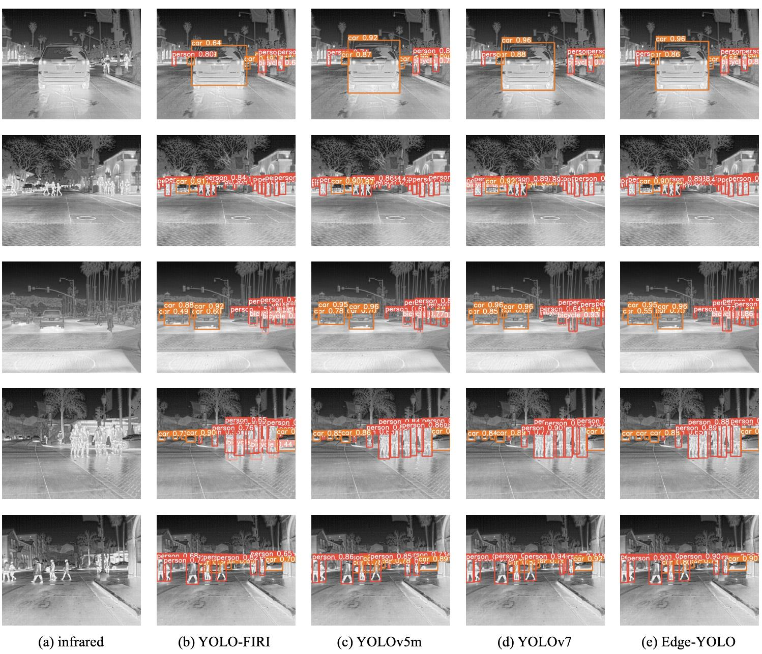
Figure 8. Part of the test results.

Since the Faster R-CNN and SSD in the previous subsection are lagging in detection accuracy and detection speed, only YOLO-FIRI, YOLOv5m, and YOLOv7 are used in the visualization effect comparison with the algorithms in this paper.
From the figure, it can be seen that compared with YOLO-FIRI, the target detection algorithm for infrared road scenes, the algorithm in this paper has a certain lead in accuracy and a higher confidence level in detecting targets. In addition, observing the fourth figure, we can see that the YOLO-FIRI algorithm misdetects some pedestrian legs as bicycles, which has some defects. After comparing this algorithm with the YOLOv5m algorithm and YOLOv7 algorithm, we can see that the three algorithms basically maintain the same detection results, and they can detect cars, pedestrians, and a small number of bicycles in road scenes well. Because the algorithm in this paper is a lightweight network model, it is better than the other two algorithms in terms of the number of parameters, computation, and model size, so this algorithm has a more practical application value.
4.7. Actual Edge Device Deployment Testing
This paper uses the RK3588 embedded development board of Rockchip as the verification platform, as shown in Figure 9 below. RK3588 platform is equipped with quad-core A76+ quad-core A55, an octa-core CPU, and NPU with 6TOPs computation power. Its high computation power NPU supports INT4, INT8, INT16, and FP16 mixed computing, which can accelerate the inference of network models. The photo of RK3588 is shown below.
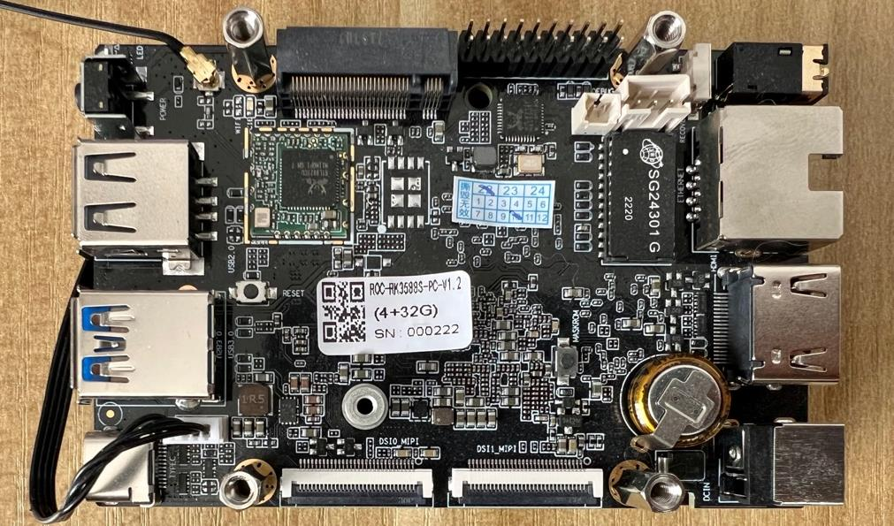
Figure 9. The RK3588 embedded development board.

The algorithm model in this paper and the comparison algorithm model are first exported to the compatible ONNX format, and then converted to the RKNN model supported by the NPU of the RK3588 platform using the RKNN-Toolkit2 and rknpu2 tools with inference acceleration such as asymmetric hybrid quantization, and these models are used to infer the test set images, and the performance comparison is obtained as shown in the following table. In addition to inference using NPU, the performance of only CPU inference is also tested in this paper and is shown together in Table 4 below.
Table 4. Testing results on the RK3588 platform.
Model | mAP@0.5/% | FPS(CPU) | FPS(NPU)
YOLO-FIRI | 73.0 | 0.8 | 21.6
YOLOv5m | 79.1 | 0.5 | 14.5
YOLOv7 | 81.2 | 0.3 | 8.8
Edge-YOLO | 78.6 | 1.1 | 31.9

As can be seen from the table, the accuracy of all four models on the RK3588 platform has a slight decrease due to model quantization. In addition, if only the ARM CPU is used for inference, the FPS of algorithms such as YOLO-FIRI is less than 1, i.e., the number of images that can be inferred is less than one per second, and the algorithm in this paper only has an FPS of 1.1, which cannot be deployed in practical application scenarios. After using NPU to accelerate, we can see that the inference speed of each algorithm was improved by tens of times. However, the FPS of YOLOv5m and YOLOv7 are only 14.5 and 8.8, respectively, which are more obvious to notice lags in real-world applications, while the algorithm in this paper can achieve 31.9 FPS, which can meet the performance requirements of practical scenarios.
5. Conclusions
The proposed method in this paper, Edge-YOLO, is a lightweight IR target detection approach that aims to ensure good performance in road scenes and is suitable for edge-embedded devices. The algorithm utilizes an optimized bounding box loss function, the improved EX-IoU, to enhance the regression accuracy of the bounding box. Moreover, to improve the up-sampling effect, the algorithm adopts the improved CAU-Lite up-sampling operator, which perceives the contextual content. Lastly, the lightweight ShuffleBlock replaces the backbone feature extraction part of the network, and the strip depthwise convolutional attention module is used to enhance the extraction capability of strip-shaped targets and other salient features present in the IR feature map for the ShuffleBlock, thus further enhancing the detection accuracy of the model. The experimental results on the FLIR dataset demonstrate that Edge-YOLO is essentially equivalent to YOLOv5m in terms of accuracy, while reducing the number of network parameters, computation, and model size by 72.2%, 70.3%, and 71.6%, respectively. Additionally, the detection speed is increased by 44.4%, making the algorithm more suitable for embedded device applications.
Author Contributions
Conceptualization, J.Y.; methodology, J.L.; software, J.L.; validation, J.L.; writing—original draft preparation, J.L.; writing—review and editing, J.L. and J.Y.; supervision, J.Y. All authors have read and agreed to the published version of the manuscript.
Institutional Review Board Statement
Not applicable.
Informed Consent Statement
Not applicable.
Data Availability Statement
Not applicable.
Conflicts of Interest
The authors declare no conflict of interest.
References
1. Chen C.P. Li H. Wei Y. Xia T. Tang Y.Y. A local contrast method for small infrared target detection IEEE Trans. Geosci. Remote Sens. 2013 52 574 581 10.1109/TGRS.2013.2242477
2. Liu R. Lu Y. Gong C. Liu Y. Infrared point target detection with improved template matching Infrared Phys. Technol. 2012 55 380 387 10.1016/j.infrared.2012.01.006
3. Teutsch M. Muller T. Huber M. Beyerer J. Low resolution person detection with a moving thermal infrared camera by hot spot classification Proceedings of the IEEE Conference on Computer Vision and Pattern Recognition Workshops Columbus, OH, USA 23–28 June 2014 209 216
4. Ren S. He K. Girshick R. Sun J. Faster r-cnn: Towards real-time object detection with region proposal networks Proceedings of the Advances in Neural Information Processing Systems Montreal, QC, Canada 7–12 December 2015 Volume 28
5. Liu W. Anguelov D. Erhan D. Szegedy C. Reed S. Fu C.Y. Berg A.C. Ssd: Single shot multibox detector Proceedings of the 14th European Conference on Computer Vision Amsterdam, The Netherlands 11–14 October 2016 Springer Cham, Switzerland 2016 21 37
6. Redmon J. Divvala S. Girshick R. Farhadi A. You only look once: Unified, real-time object detection Proceedings of the IEEE Conference on Computer Vision and Pattern Recognition Amsterdam, The Netherlands 11–14 October 2016 779 788
7. Redmon J. Farhadi A. Yolov3: An incremental improvement arXiv 2018 1804.02767
8. Wang C.Y. Liao HY M. Wu Y.H. Chen P.Y. Hsieh J.W. Yeh I.H. CSPNet: A new backbone that can enhance the learning capability of CNN Proceedings of the IEEE/CVF Conference on Computer Vision and Pattern Recognition Workshops Seattle, WA, USA 14–19 June 2020 390 391
9. He K. Zhang X. Ren S. Sun J. Spatial pyramid pooling in deep convolutional networks for visual recognition IEEE Trans. Pattern Anal. Mach. Intell. 2015 37 1904 1916 10.1109/TPAMI.2015.2389824
10. Li S. Li Y. Li Y. Li M. Xu X. YOLO-FIRI: Improved YOLOv5 for Infrared Image Object Detection IEEE Access 2021 9 141861 141875 10.1109/ACCESS.2021.3120870
11. Fan Y. Qiu Q. Hou S. Li Y. Xie J. Qin M. Chu F. Application of Improved YOLOv5 in Aerial Photographing Infrared Vehicle Detection Electronics 2022 11 2344 10.3390/electronics11152344
12. Dai X. Yuan X. Wei X. TIRNet: Object detection in thermal infrared images for autonomous driving Appl. Intell. 2021 51 1244 1261 10.1007/s10489-020-01882-2
13. Li B. Xiao C. Wang L. Wang Y. Lin Z. Li M. An W. Guo Y. Dense nested attention network for infrared small target detection IEEE Trans. Image Process. 2022 32 1745 1758 10.1109/TIP.2022.3199107 35994532
14. You S. Ji Y. Liu S. Mei C. Yao X. Feng Y. A thermal infrared pedestrian-detection method for edge computing devices Sensors 2022 22 6710 10.3390/s22176710 36081166
15. Zheng Z. Wang P. Liu W. Li J. Ye R. Ren D. Distance-IoU loss: Faster and better learning for bounding box regression Proc. AAAI Conf. Artif. Intell. 2020 34 12993 13000 10.1609/aaai.v34i07.6999
16. Zhang Y.-F. Ren W. Zhang Z. Jia Z. Wang L. Tan T. Focal and efficient IOU loss for accurate bounding box regression Neurocomputing 2022 506 146 157 10.1016/j.neucom.2022.07.042
17. He J. Erfani S. Ma X. Bailey J. Chi Y. Hua X.S. Alpha-IoU: A Family of Power Intersection over Union Losses for Bounding Box Regression Adv. Neural Inf. Process. Syst. 2021 34 20230 20242
18. Lin T.Y. Dollár P. Girshick R. He K. Hariharan B. Belongie S. Feature pyramid networks for object detection Proceedings of the IEEE Conference on Computer Vision and Pattern Recognition Honolulu, HI, USA 21–26 July 2017 2117 2125
19. Wang J. Chen K. Xu R. Liu Z. Loy C.C. Lin D. Carafe: Content-aware reassembly of features Proceedings of the IEEE Conference on Computer Vision and Pattern Recognition Seoul, Republic of Korea 27 October–2 November 2019 3007 3016
20. Ma N. Zhang X. Zheng H.T. Sun J. Shufflenet v2: Practical guidelines for efficient cnn architecture design Proceedings of the European Conference on Computer Vision (ECCV) Munich, Germany 8–14 September 2018 116 131
21. Hu J. Shen L. Sun G. Squeeze-and-excitation networks Proceedings of the IEEE Conference on Computer Vision and Pattern Recognition Salt Lake City, UT, USA 18–23 June 2018 7132 7141
22. Wang C.Y. Bochkovskiy A. Liao H.Y.M. YOLOv7: Trainable bag-of-freebies sets new state-of-the-art for real-time object detectors arXiv 2022 2207.02696
Disclaimer/Publisher’s Note: The statements, opinions and data contained in all publications are solely those of the individual author(s) and contributor(s) and not of MDPI and/or the editor(s). MDPI and/or the editor(s) disclaim responsibility for any injury to people or property resulting from any ideas, methods, instructions or products referred to in the content.
二、英文翻译
Edge-YOLO：部署于边缘设备的轻量化红外目标检测方法
摘要
现有面向红外道路场景的目标检测算法通常计算量较大、模型规模较大，因此不适合直接部署在边缘设备上。针对这一问题，原文提出了一种轻量化红外目标检测方法 Edge-YOLO。该方法将 YOLOv5m 的主干网络替换为轻量化 ShuffleBlock，并引入条形深度可分离卷积注意力模块；同时采用 CAU-Lite 作为上采样算子，采用 EX-IoU 作为边界框损失函数。实验结果表明，与 YOLOv5m 相比，Edge-YOLO 的计算量降低 70.3%，模型大小减少 71.6%，检测速度提升 44.4%，同时保持了相近的检测精度。因此，该方法更适合部署在嵌入式平台上，有助于在真实场景中实现有效的红外目标检测。
关键词
红外目标检测；轻量化网络；卷积注意力；YOLOv5；RK3588
1. 引言
可见光图像由于分辨率高、清晰度较好，并且包含人眼容易理解的细节信息，常被用于目标检测任务。然而，可见光图像容易受到天气、光照等外部因素影响，图像质量下降后会直接影响目标检测精度。红外成像技术能够在雾天、夜间等复杂光照和天气条件下获取图像，因此在自动驾驶、安防监控和遥感等领域得到应用，其适用场景比普通可见光图像更广。由此可见，红外成像技术对于实现稳定可靠的目标检测具有重要意义。
传统红外目标检测方法主要依赖模板匹配、阈值分割和 Hausdorff 度量等模型驱动方法。随着深度学习的发展，基于卷积神经网络的目标检测方法逐渐成为主流。这类方法通常可以分为两阶段算法和单阶段算法，前者以 Faster R-CNN 为代表，后者以 SSD 和 YOLO 为代表。单阶段算法在检测速度和检测精度之间取得了较好的平衡，因此 YOLO 系列成为应用较广的一类检测方法。YOLOv5 在可见光图像上具有较好的检测精度和速度，但直接用于红外图像检测时仍会遇到一些问题。红外图像通常对比度较低、噪声较多、成像较模糊，目标关键特征在深层卷积处理过程中可能丢失；同时，红外图像缺少颜色信息，目标与背景之间的差异较小，使网络更难区分有效特征和无关信息。另一方面，自动驾驶和安防监控等场景中的嵌入式设备通常计算能力、存储空间和功耗都受到限制，而这些场景又要求实时检测，因此将大型目标检测模型部署到边缘设备上存在较大难度。如果将边缘设备采集的数据发送到服务器端进行检测和分析，在分布式场景中还可能带来网络延迟和通信拥塞问题。
上述问题说明，在边缘设备上进行轻量化红外目标检测具有必要性。针对这些问题，原文提出了 Edge-YOLO，一种面向边缘设备的红外目标检测算法。该算法使用轻量化网络结构和注意力机制，主要改进包括三个方面：第一，重新设计边界框损失函数，引入带有幂超参数 α 的损失项，以加快损失函数收敛并减弱 CIoU 中长宽比项带来的不确定性；第二，采用轻量化的内容感知上采样算子，在仅增加少量参数和计算量的情况下，比最近邻上采样获得更大的感受野；第三，基于改进的 ShuffleNetv2 重构特征提取网络，并在 ShuffleBlock 中嵌入条形深度可分离卷积注意力模块，以增强红外场景中条形特征的提取能力，同时降低网络计算量。
原文后续结构如下：第二部分介绍与神经网络目标检测、YOLOv5 以及红外目标检测算法相关的研究；第三部分详细说明 Edge-YOLO 算法；第四部分给出实验结果；第五部分总结论文的主要贡献。
2. 相关工作
YOLO 系列算法以高效、结构简洁为特点，最早由 Redmon 等人在 2015 年提出。随后，研究者又陆续发布了 YOLOv2 和 YOLOv3，并在检测精度与速度之间持续改进。YOLO 系列的核心思想是将目标检测问题转化为单阶段回归问题，直接在图像上预测目标位置和类别。后来，CSPNet、SPP、PANet 等结构不断被引入 YOLO 系列模型中，以增强特征提取能力和多尺度融合能力。YOLOv5 进一步结合 Mosaic 数据增强、C3 模块和改进的 SPPF 模块，使模型在检测精度和速度上都获得了较好表现。
除 YOLOv5 外，针对红外场景的目标检测也有许多改进方法。例如，有研究提出 YOLO-FIRI 模型，用于红外图像区域特征检测；也有研究将改进的 YOLOv5 用于航拍红外车辆检测；还有一些方法面向自动驾驶中的热红外图像，或使用密集嵌套注意力网络进行红外小目标检测。这些方法在红外目标检测方面取得了一定效果，但很多模型仍然存在计算量较大、模型规模较大或实时性不足的问题。对于边缘设备而言，模型不仅要有较好的检测精度，还需要在存储占用、计算量和运行速度之间取得平衡。
3. 方法
Edge-YOLO 模型结构见原文图 2。
首先，模型主干部分使用改进的 ShuffleBlock 替换 YOLOv5 中的 C3 模块，以增强红外图像特征提取能力，并降低参数量和计算量。
其次，在特征上采样结构中，原来的最近邻上采样算子被改进后的 CAU-Lite 模块替换，以提高特征融合时的上下文感知能力。
第三，虽然图中没有直接展示，但模型使用新提出的 EX-IoU 替代 CIoU 作为边界框损失函数。新的损失函数可以为边界框回归提供更稳定的优化方向。
图 2. Edge-YOLO 的网络结构。
3.1 改进的边界框损失函数 EX-IoU
YOLOv5 6.2 版本采用 Complete-IoU（CIoU）作为边界框损失函数。CIoU 同时考虑预测框与真实框之间的交并比、两个中心点之间的归一化距离，以及长宽比相似性。其公式可表示为：
$$L_{CIoU}=1-IoU+\frac{ρ^{2}(b,b^{gt})}{c^{2}}+αv$$  $$α=\frac{v}{\left((1-IoU)+v\right)}$$  $$v=\frac{4}{π^{2}}{\left(arctan\frac{w^{gt}}{h^{gt}} - arctan\frac{w}{h}\right)}^{2}$$ | (1)
其中，α 为权重系数，ρ(b,b^gt) 表示预测框中心点与真实框中心点之间的距离，c 表示最小外接矩形的对角线长度，v 表示预测框与真实框长宽比之间的差异。
CIoU 虽然综合考虑了多种几何因素，但其中的长宽比项属于相对值，在计算过程中可能引入不确定性，进而影响模型优化。为了解决这一问题，原文采用 Efficient-IoU（EIoU）作为边界框损失函数。EIoU 将长宽比项拆分，用预测框与真实框之间的宽度差和高度差来替代原来的长宽比差异，使边界框损失函数更加直接，有利于模型优化。其公式为：
$$L_{EIoU}=1-IoU+\frac{ρ^{2}(b,b^{gt})}{c^{2}}+\frac{ρ^{2}(w,w^{gt})}{{C_{w}}^{2}}+\frac{ρ^{2}(h,h^{gt})}{{C_{h}}^{2}}$$ | (2)
其中，C_w 和 C_h 分别表示最小外接矩形的宽度和高度。相关研究进一步提出，在 IoU 损失函数的各项中引入超参数 α 作为幂指数，其简化公式为：
$$L_{α-IoU}=1-{IoU}^{α}$$ | (3)
参数 α 可以强调高 IoU 目标的损失和梯度，从而提高边界框回归精度。基于这一思想，原文将幂指数 α 引入 EIoU 公式，提出 EX-IoU。该函数会对预测框与真实框之间的 IoU 值、中心距离、宽度差和高度差的重要性进行指数形式放大，从而起到减小损失、提升边界框回归精度的作用。α 的最优取值由实验确定。EX-IoU 的公式如下：
$$L_{EX-IoU}=1-{IoU}^{α}+\frac{ρ^{2α}(b,b^{gt})}{c^{2α}}+\frac{ρ^{2α}(w,w^{gt})}{{C_{w}}^{2α}}+\frac{ρ^{2α}(h,h^{gt})}{{C_{h}}^{2α}}$$ | (4)
3.2 内容感知轻量化上采样算子 CAU-Lite
上采样是特征金字塔网络中的关键操作。常见的上采样方法包括线性插值和反卷积。最近邻插值、双线性插值等线性插值方法只考虑当前像素的局部邻域，因此语义信息不足，感受野也较小。反卷积方法虽然通过卷积扩展特征图维度，但其在整张特征图上使用相同的卷积核，难以捕捉局部变化，同时还会引入较多参数和额外计算量。CARAFE 在一定程度上弥补了上述方法的不足。它能够在更大的感受野内感知和聚合上下文信息，不再对所有特征使用固定卷积核，而是动态生成自适应上采样核，并根据预测得到的上采样核重新组织特征。CARAFE 的上采样核预测模块通过卷积改变输入特征图的通道维度，生成上采样核图；随后在特征重组阶段，将输出特征图中的每个空间位置映射回输入特征图中对应区域，并与预测得到的上采样核进行加权运算。
但是，CARAFE 在特征重组阶段对特征图边缘位置采用零填充策略，这会导致上采样图像的边缘信息不完整，位于特征图边缘的目标特征也可能无法被正确上采样。基于这一问题，原文提出了改进的 Content-Aware Up-Sampling-Lite（CAU-Lite）方法，用于替代 YOLOv5 中的最近邻上采样。该方法在寻找 k_up × k_up 邻域之前，先对输入特征图进行最近邻插值，使特征图的空间尺寸与上采样核图保持一致。随后，在每个空间位置上，将对应的特征邻域和上采样核重新调整形状，并按通道进行乘积和求和，得到该位置的输出特征。改进后的 CAU-Lite 结构和计算过程见原文图 3。
3.3 YOLOv5 网络模型改进
YOLOv5 主要面向可见光图像设计，模型参数量和计算量较大，更适合部署在 GPU 上。Edge-YOLO 的目标是在边缘嵌入式设备上构建轻量化目标检测网络，因此用轻量化网络结构替换 YOLOv5 中较重的 CSPDarknet 主干网络是合理的选择。ShuffleNetv2 在模型精度和运行速度之间取得了较好平衡，通过分组卷积、深度可分离卷积等轻量化结构降低计算复杂度和存储访问成本，从而提升实际运行速度。红外道路场景通常具有两个特点。第一，与可见光图像相比，红外图像缺少丰富纹理和复杂特征，深层复杂网络中更容易出现特征丢失，并可能引入额外噪声。第二，在道路场景中，行人、自行车等目标往往呈现细长条状，而不是规则形状。传统卷积核通常为规则方形卷积核，难以适应目标形状变化，可能导致特征信息损失。
为了在不明显增加计算量的情况下增强条形目标特征提取能力，原文在 ShuffleBlock 中嵌入条形深度可分离卷积注意力模块（SDCA）。SDCA 首先通过 5 × 5 深度卷积聚合局部信息，然后使用 1 × 7 与 7 × 1、1 × 11 与 11 × 1 等条形卷积分支捕获多尺度上下文信息和条形特征。各分支结果相加后，再通过 1 × 1 卷积建模通道关系，并将输出作为注意力权重作用于输入特征。
原文还在右分支中加入 SENet 作为通道注意力机制，并对 ShuffleBlock 结构进行了进一步简化。原始 ShuffleBlock 在深度卷积前后都使用 1 × 1 卷积进行通道信息融合和通道数调整，但这会带来一定冗余。为了减少参数量和计算需求，原文移除了深度卷积之后的 1 × 1 卷积层。
4. 实验
4.1 实验环境与数据集
原文实验使用 Intel Xeon Platinum 8255C CPU 和 NVIDIA RTX 3090 GPU，CUDA 版本为 11.7。为了评价 Edge-YOLO 的检测性能，实验使用 FLIR 数据集。该数据集包含红外道路场景中的行人、自行车和汽车等目标。数据集按照训练集和测试集进行划分，并用于模型训练和检测性能评估。
4.2 边界框超参数研究
在改进的 EX-IoU 边界框损失函数中，超参数 α 会影响模型精度。为了确定适合该模型的 α 取值，原文设置了多组 α 进行实验，并比较不同取值下的检测效果。实验结果表明，α 取值会影响边界框回归效果和最终检测精度，因此需要通过实验选择较优参数，而不能简单使用固定默认值。
图 6. 不同 α 取值对算法精度的影响。
4.3 模型轻量化实验
通过将 YOLOv5 的主干特征提取网络替换为改进后的 ShuffleBlock，算法模型的参数量、计算量和模型大小都可以有效降低。原文将轻量化后的 Edge-YOLO 与 YOLOv5m 在参数量、计算量和模型大小等方面进行了对比。
表 1. 轻量化改进效果对比。YOLOv5m：参数量 20.9M，计算量 47.9G，模型大小 42.2MB；Edge-YOLO：参数量 5.8M，计算量 14.2G，模型大小 12.0MB。
实验结果表明，使用改进的 ShuffleBlock 替换主干网络后，与 YOLOv5m 相比，Edge-YOLO 的网络参数量减少了 72.2%，计算量减少了 70.3%，模型大小减少了 71.6%。这说明所提出的方法具有明显的轻量化效果，有助于降低模型对存储资源和计算资源的需求，更适合部署在资源受限的边缘嵌入式设备上。
4.4 消融实验
在这一部分，原文首先使用原始 ShuffleNetv2 作为 YOLOv5m 的主干网络，在此基础上对提出的多个改进策略进行消融实验，包括 EX-IoU、CAU-Lite 和 SDCA。通过逐步加入不同模块，可以观察每个模块对检测精度、速度、参数量和计算量的影响。
表 2. 消融实验。基础模型的 mAP@0.5 为 73.1%，FPS 为 85.3，参数量为 5.4M，计算量为 12.9G，模型大小为 11.3MB；加入 EX-IoU 后 mAP@0.5 提升到 74.3%；加入 CAU-Lite 后 mAP@0.5 为 74.7%；加入 SDCA 后 mAP@0.5 为 76.2%；同时加入 EX-IoU、CAU-Lite 和 SDCA 后，mAP@0.5 提升到 78.8%，FPS 为 80.7，参数量为 5.8M，计算量为 14.2G，模型大小为 12.0MB。
从表 2 可以看出，与仅使用基础模型相比，加入 EX-IoU 后模型精度有所提升；加入 CAU-Lite 后，由于上采样过程能够更好地利用上下文信息，检测性能进一步改善；加入 SDCA 后，模型对红外图像中条形目标和显著特征的提取能力增强，精度提升更加明显。完整 Edge-YOLO 综合使用三个模块，在保持较小模型规模的同时获得了最高的 mAP@0.5。
图 7. 各类别的 P-R 曲线，包括 Person、Bicycle、Car 以及全部类别的 P-R 曲线。
4.5 对比实验
为了进一步验证 Edge-YOLO 的检测性能，原文将其与 Faster R-CNN、SSD、YOLOv5m、YOLOv7 和 YOLO-FIRI 等主流目标检测算法进行了对比。
表 3. 主流目标检测算法对比。Faster R-CNN 的 mAP@0.5 为 70.9%，FPS 为 17.6；SSD 的 mAP@0.5 为 62.1%，FPS 为 31.9；YOLOv5m 的 mAP@0.5 为 79.5%，FPS 为 55.9；YOLOv7 的 mAP@0.5 为 81.7%，FPS 为 27.9；YOLO-FIRI 的 mAP@0.5 为 73.5%，FPS 为 71.4；Edge-YOLO 的 mAP@0.5 为 78.8%，FPS 为 80.7，参数量和计算量也更低。
从对比结果可以看出，Faster R-CNN 作为两阶段算法，在检测速度上明显落后于单阶段算法，且精度并没有优势。YOLOv5m 和 YOLOv7 具有较高精度，但参数量和计算量较大，不利于边缘设备部署。YOLO-FIRI 速度较快，但检测精度相对较低。Edge-YOLO 在保持接近 YOLOv5m 检测精度的同时，获得了更高的检测速度、更少的参数量和更低的计算量，说明其在边缘部署场景中具有较好综合性能。
4.6 测试结果对比
图 8 展示了 YOLO-FIRI、YOLOv5m、YOLOv7 和 Edge-YOLO 在数据集部分图像上的检测结果。
由于 Faster R-CNN 和 SSD 在前一小节中检测精度和检测速度都相对落后，原文在可视化实验中只选择 YOLO-FIRI、YOLOv5m 和 YOLOv7 作为对比算法。
从图中可以看出，与面向红外道路场景的 YOLO-FIRI 相比，Edge-YOLO 在检测精度和定位效果上具有一定优势；与 YOLOv5m 和 YOLOv7 相比，Edge-YOLO 在保持较好检测效果的同时显著降低了模型规模和计算量。对于红外图像中对比度较低、目标边界不清晰的情况，Edge-YOLO 能够较好地检测出目标，体现了轻量化结构和注意力模块的有效性。
4.7 实际边缘设备部署测试
原文采用瑞芯微 RK3588 嵌入式开发板作为验证平台。RK3588 平台配备四核 Cortex-A76 与四核 Cortex-A55 CPU 架构，并集成算力为 6 TOPS 的 NPU。该 NPU 支持 INT4、INT8、INT16 和 FP16 等混合计算方式，可用于加速神经网络模型推理。图 9 为 RK3588 嵌入式开发板。
原文中的算法模型和对比模型首先导出为 ONNX 格式，然后利用 RKNN-Toolkit2 和 rknpu2 工具转换为 RK3588 NPU 支持的 RKNN 模型。在转换和部署过程中，使用了非对称混合量化等推理加速方法。转换后的模型用于测试集图像推理，同时原文还测试了仅使用 CPU 推理时的性能，并与 NPU 推理结果进行对比。
表 4. RK3588 平台测试结果。YOLO-FIRI 的 mAP@0.5 为 73.0%，CPU 推理 FPS 为 0.8，NPU 推理 FPS 为 21.6；YOLOv5m 的 mAP@0.5 为 79.1%，CPU FPS 为 0.5，NPU FPS 为 14.5；YOLOv7 的 mAP@0.5 为 81.2%，CPU FPS 为 0.3，NPU FPS 为 8.8；Edge-YOLO 的 mAP@0.5 为 78.6%，CPU FPS 为 1.1，NPU FPS 为 31.9。
部署结果显示，由于模型量化，四种模型在 RK3588 平台上的精度均出现了轻微下降。如果只使用 ARM CPU 推理，YOLO-FIRI 等算法的 FPS 小于 1，Edge-YOLO 也只有约 1.1 FPS，无法满足实际部署需求。启用 NPU 加速后，各算法推理速度均提高了数十倍。YOLOv5m 和 YOLOv7 分别达到 14.5 FPS 和 8.8 FPS，而 Edge-YOLO 可以达到 31.9 FPS，能够满足实际场景中的性能要求。
5. 结论
Edge-YOLO 是一种面向道路场景和边缘嵌入式设备的轻量化红外目标检测方法。该算法通过改进的 EX-IoU 边界框损失函数提升边界框回归精度；通过 CAU-Lite 上采样算子在特征融合过程中感知上下文信息；同时使用轻量化 ShuffleBlock 替换主干特征提取网络，并利用条形深度可分离卷积注意力模块增强红外特征图中条形目标和显著特征的提取能力。
在 FLIR 数据集上的实验结果表明，Edge-YOLO 在检测精度上与 YOLOv5m 基本相当，同时参数量、计算量和模型大小分别降低了 72.2%、70.3% 和 71.6%，检测速度提高了 44.4%。因此，该算法更适合嵌入式设备应用。

附录B 课题调研报告
一、课题目的和意义
本课题的实际目标，是把目标检测模型从PC端训练和离线验证推进到RK3588嵌入式平台上的可运行系统。相比只报告mAP等离线指标，板端系统还需要处理模型格式转换、运行时兼容、视频输入输出、线程调度、内存占用和长时间稳定性等问题。本文选择无人机小目标检测作为应用场景，是因为这类任务对实时性和边缘部署都有较高要求，也能比较清楚地暴露端侧AI系统从模型到工程实现之间的差距。
二、课题的作用与思考
本课题的作用主要体现在把模型检测结果接入可运行的视频链路。通过固定视频检测、RTSP实时推流和事件日志记录，系统能够把算法输出转化为可观察、可复查的实验结果。多线程流水线、多context NPU并行、检测间隔控制、动态ROI、轻量跟踪和软件报警提示等设计，都是围绕“能否在低功耗开发板上稳定演示”这一问题展开的。与此同时，视觉检测系统仍可能受到光照、遮挡、背景干扰和模型误检影响，因此在实际使用中仍需要阈值调节、日志追踪和人工复核机制配合，不能把模型输出简单等同于最终安全判断。
三、课题的建议与构想
后续工作可以从模型、系统和应用三个层面继续推进。模型层面，应继续分析hybrid INT8与FP基线方案之间的精度和速度差异，进一步明确full INT8置信度塌缩的原因；系统层面，可进一步完善RGA 硬件预处理、zero-copy 输入和统一性能日志，使每次优化均能在同一公开视频和同一组指标下复现；应用层面，如果未来需要接入真实报警设备，应将当前软件报警接口抽象为统一事件输出层，再按场景连接GPIO、网络消息或上位机平台，避免将外设控制逻辑固化在检测程序中。

